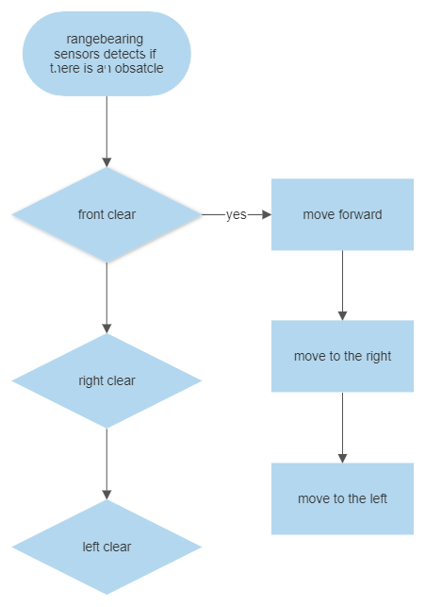

Create a function that checks for obstacles

User inputs so the robot starts moving

no

no

stop

Yes

no

yes

Yes

Target reached